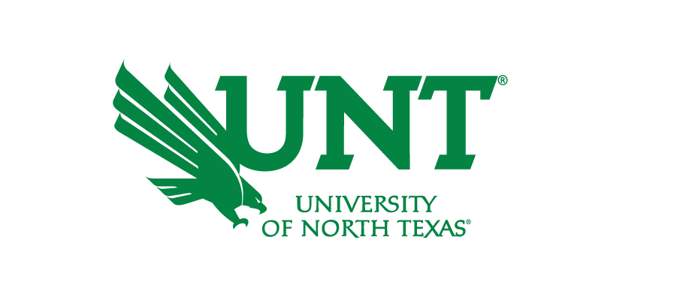

Fall 2021 Admissions Updates

Admissions  Requirements | The University of North Texas is test optional for students applying for Fall 2021. We will be reviewing applications and making decisions based on the student’s cumulative unweighted high school GPA. Students can review our automatic admissions requirements HERE.  We will accept high school transcripts by email at unt.freshmen@unt.edu as long as they are being send by a high school counselor, or sent from the student’s school via an electronic transcript service from current high school students or high school counselors.  The requirements for obtaining an application fee waiver for Summer and Fall 2020 have not change changed. For additional information and updates, visit our Fee Waiver webpage.  We do have several ways students, parents, and counselors can reach us. You can find the information on our Ways to Connect Page.
Deadlines | Freshman Applicants for Fall 2021: March 1, 2021  Transfer Applicants for Fall 2021: July, 1, 2021
Campus Tours | UNT has limited in-person tours and virtual tours available! To sign up for a tour, please click HERE.  Our open house, UNT Preview, will be hosted virtual during different Saturdays. Students can RSVP on the website, and they will receive an email with instructions on how to join.  UNT Transfer Debuts, an open house for our Transfer Students, will be held virtually. Have any questions, email unt.transfer@unt.edu.
Orientation | The Orientation team will be updating Freshman and Transfer Orientations information on their website as changes are made in respond to COVID-19. Currently Orientations for students starting in the Spring are virtual. If you have questions, you can reach out via email at freshman@unt.edu OR transfer@unt.edu.
Financial Aid | Please contact the Financial Aid and Scholarships office with any questions about financial aid through live chat online, by phone or through email.
TSI | For more information, visit the TSI Website.
COVID-19 FAQ | Healthalerts.unt.edu

