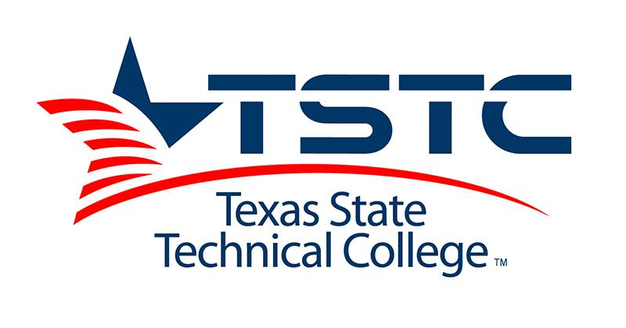

Fall 2020 Admissions Updates

Admissions  Requirements | Currently offering applicants conditional enrollment, applicants must submit bacterial meningitis vaccination if under 22, and complete all enrollment requirements before registration.  For help on general questions regarding admissions sign onto QLESS by texting “TSTC” to 956-625-9243  or sign in through our website by visiting  https://kiosk.na4.qless.com/kiosk/app/home/60
Registration Opens | April 6 for returning students & April 13th is registration for New students.
Campus Tours | We anticipate resuming on-campus events on May 4. In the meantime, you can book a virtual visit that is hosted by one of our Recruitment Specialists. Our programs are available for tours and further information upon request. https://tstc.edu/campuses/tour
Orientation | New Students should register for TSTC classes first. Once registered, the new student will receive an email from an Enrollment Coach or the office of New Student Orientation with the next steps. Students and parents can visit tstc.edu/nso/har for more information.
Financial Aid | Students need to apply for FAFSA 2020-2021 year, they can apply at https://studentaid.gov/  School Code: 003634
TSI | TSIA: If you would like to take the TSIA virtually online, please contact us at testing@tstc.edu. Please note that virtual online testing is scheduled to launch on May 1st via Examity and ProctorU.
COVID-19 FAQ | https://www.tstc.edu/coronavirus/stufaq?_ga=2.228320157.1667052853.1585574882-1819640709.1575575342
Additional Resources | https://docs.google.com/document/d/1s3B78YTQFE-WgbOj6J2P3rzGVuWQpeCqnWvh1EdLdKU/edit

